#include <stdio.h>

float calculateTransportation() {
float fuel;
printf("\nEnter monthly vehicle fuel consumption (liters): ");
scanf("%f", &fuel);

float EF_FUEL = 2.31; // kg CO2 per liter fuel
return fuel * EF_FUEL;
}

float calculateEnergy() {
float electricity, lpg;
printf("\nEnter monthly electricity usage (kWh): ");
scanf("%f", &electricity);

printf("Enter monthly LPG usage (kg): ");
scanf("%f", &lpg);

float EF_ELEC = 0.82; // kg CO2 per kWh
float EF_LPG = 2.95; // kg CO2 per kg LPG

return electricity * EF_ELEC + lpg * EF_LPG;
}

float calculateFood() {
float meat, vegetables, rice;

printf("\nEnter monthly meat consumption (kg): ");
scanf("%f", &meat);

printf("Enter monthly vegetable consumption (kg): ");
scanf("%f", &vegetables);

printf("Enter monthly rice consumption (kg): ");
scanf("%f", &rice);

float EF_MEAT = 27.0; // kg CO2 per kg
float EF_VEG = 2.0; // kg CO2 per kg
float EF_RICE = 4.0; // kg CO2 per kg

return meat * EF_MEAT + vegetables * EF_VEG + rice * EF_RICE;
}

void analyzeReduction(float total) {
printf("\n--- Reduction Opportunities ---\n");

if (total > 500) {
printf("• High emissions: Consider reducing fuel and electricity use.\n");
printf("• Try switching to renewable energy.\n");
printf("• Reduce meat consumption.\n");
}
else if (total > 200) {
printf("• Moderate emissions: Improve energy efficiency.\n");
printf("• Reduce unnecessary travel.\n");
}
else {
printf("• Low emissions: Great job! Maintain your habits.\n");
}
}

int main() {
float totalEmissions = 0;
int choice;
char implement;

printf("=== Household Carbon Budget Planner ===\n");

// Identify household activities (flowchart Part 1)
printf("\nIs there Transportation activity? (1=Yes, 0=No): ");
scanf("%d", &choice);
if (choice == 1)
totalEmissions += calculateTransportation();

printf("\nIs there Energy Use activity? (1=Yes, 0=No): ");
scanf("%d", &choice);
if (choice == 1)
totalEmissions += calculateEnergy();

printf("\nIs there Food Consumption activity? (1=Yes, 0=No): ");
scanf("%d", &choice);
if (choice == 1)
totalEmissions += calculateFood();

// Sum all emissions (flowchart)
printf("\n----------------------------------------\n");
printf("Total Monthly Emissions: %.2f kg CO2\n", totalEmissions);
printf("----------------------------------------\n");

// Analyze reduction opportunities (flowchart)
analyzeReduction(totalEmissions);

// Implement changes? (flowchart)
printf("\nWould you like to implement suggested changes? (Y/N): ");
scanf(" %c", &implement);

if (implement == 'Y' || implement == 'y') {
printf("\nChanges implemented. Recalculate next month for improvement.\n");
} else {
printf("\nNo changes implemented. Try reducing emissions gradually.\n");
}

printf("\n--- End of Carbon Budget Planner ---\n");

return 0;
}

OUTPUT:

Step1:

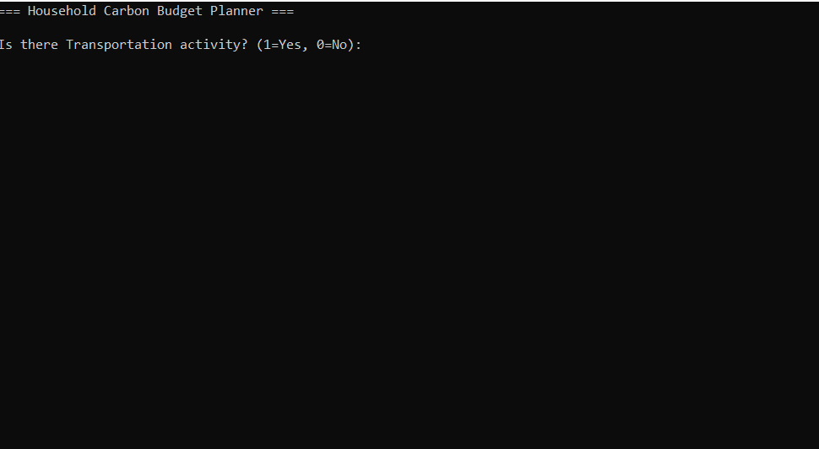

Step2:

